# Purpose

* Quickly create paste-able results into report tables
* Saves a lot of time.
* Eliminates errors

# Requirements

1. Must have Report Headers.txt
2. Only works for ‘Lanes, Volume, Timings’ and HCM 2000 Unsignalized Synchro report types
   1. Works on yield control I believe
   2. Does not work with roundabouts
3. Headers are crucial. Should be OK if Report Headers.txt is set up properly and Synchro Prep.py was used to create .sim files
   1. Synchro Prep.py was created to ensure consistent spelling in Synchro report headers. Spelling mistakes will cause script to produce unorganized results.

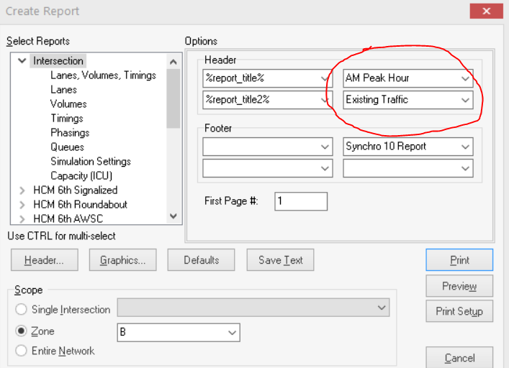

1. Group signalized intersections into one zone and unsignalized into another. Zone name can be anything you want.

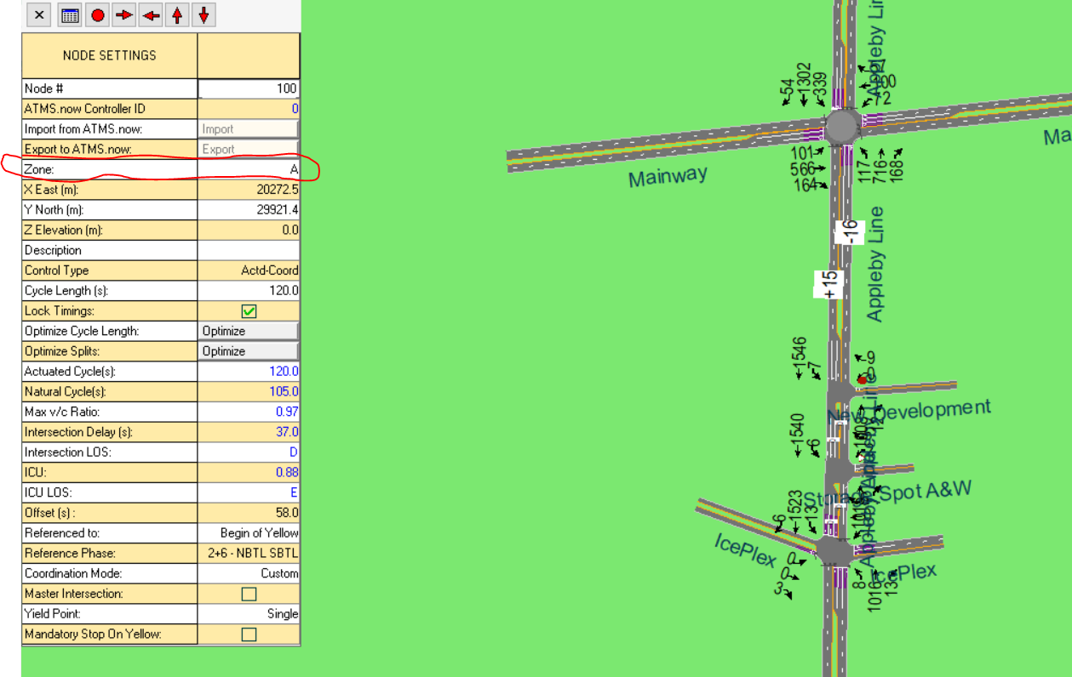

1. Must have result csv text files. Must have table templates (AWSC.docx, TWSC.docx, Signalized.docx). Report Headers.txt needs to be in the same location as the result csv text files and table templates
   1. AWSC.docx, TWSC.docx, Signalized.docx may need to be manually prepared prior to using script. E.g. adding more rows
   2. 2 column and 3 column word templates are provided

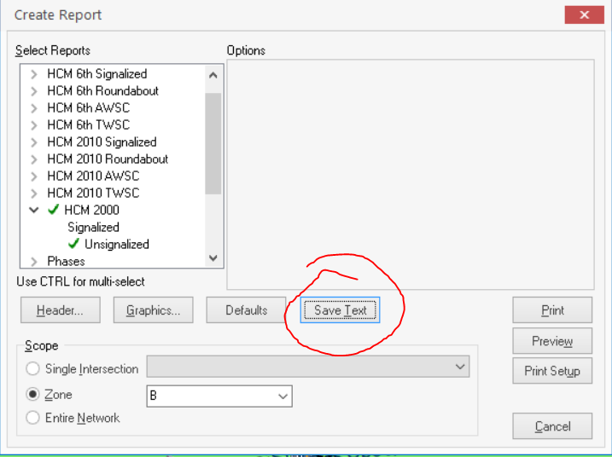

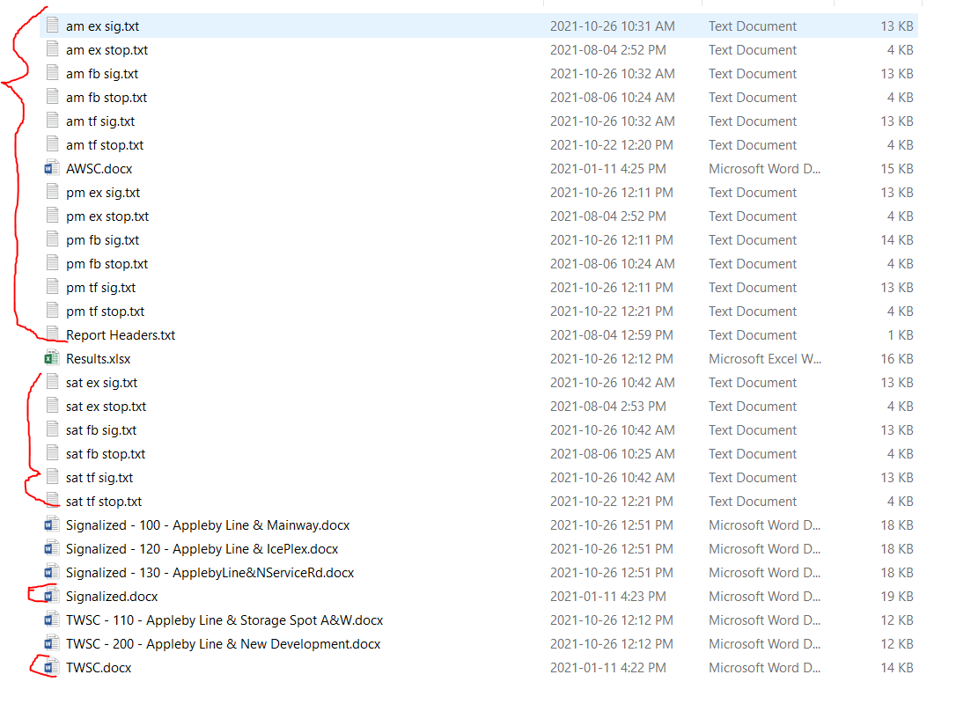

# How it works (overview)

* Script will ask for two inputs
  1. Directory of result csv text files, AWSC.docx, TWSC.docx, Signalized.docx and Report Headers.txt
  2. All results or critical results (further prompts to define critical v/c and LOS)
* Prints results into an excel file

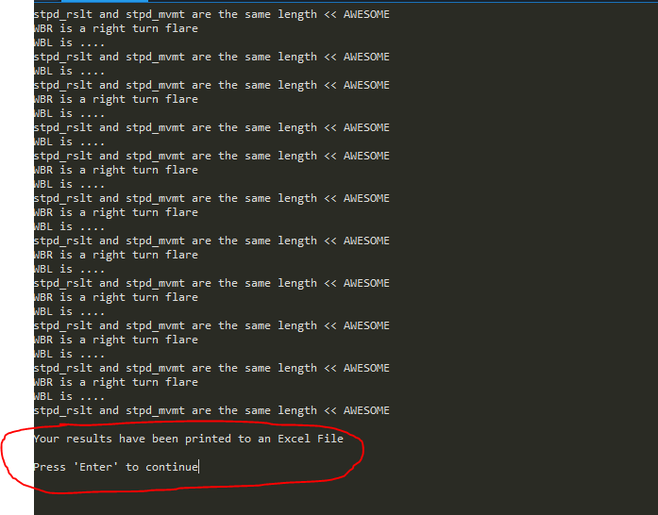

* Press ‘Enter’ to continue printing to table templates (AWSC.docx, TWSC.docx, Signalized.docx)

# Output

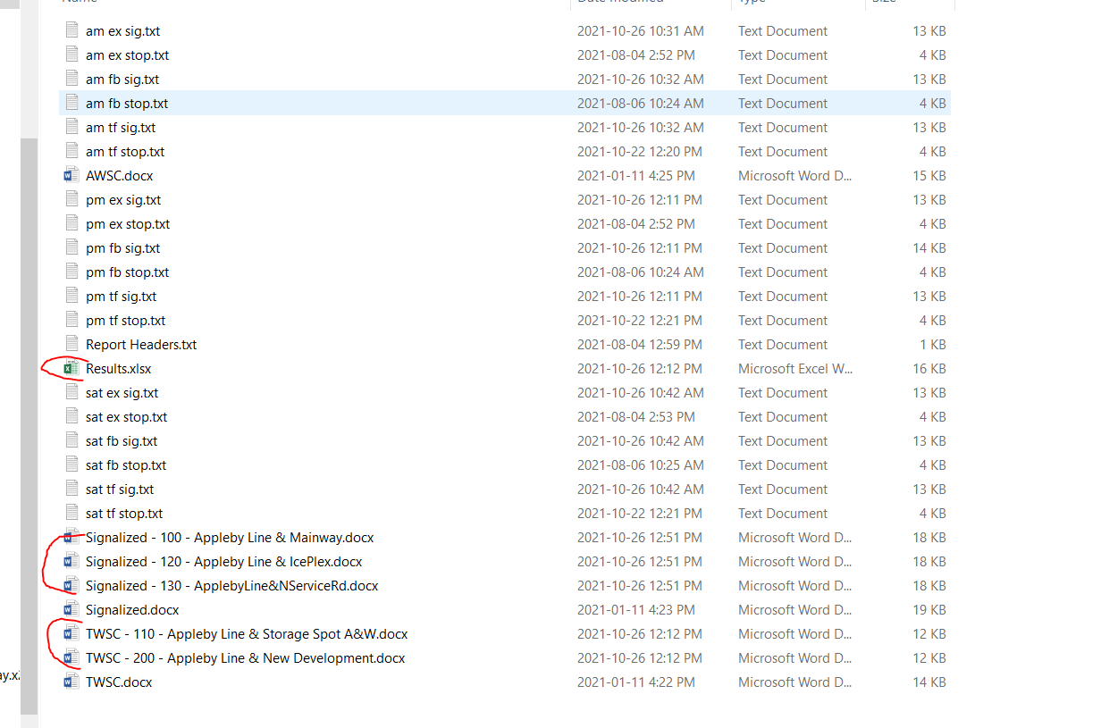

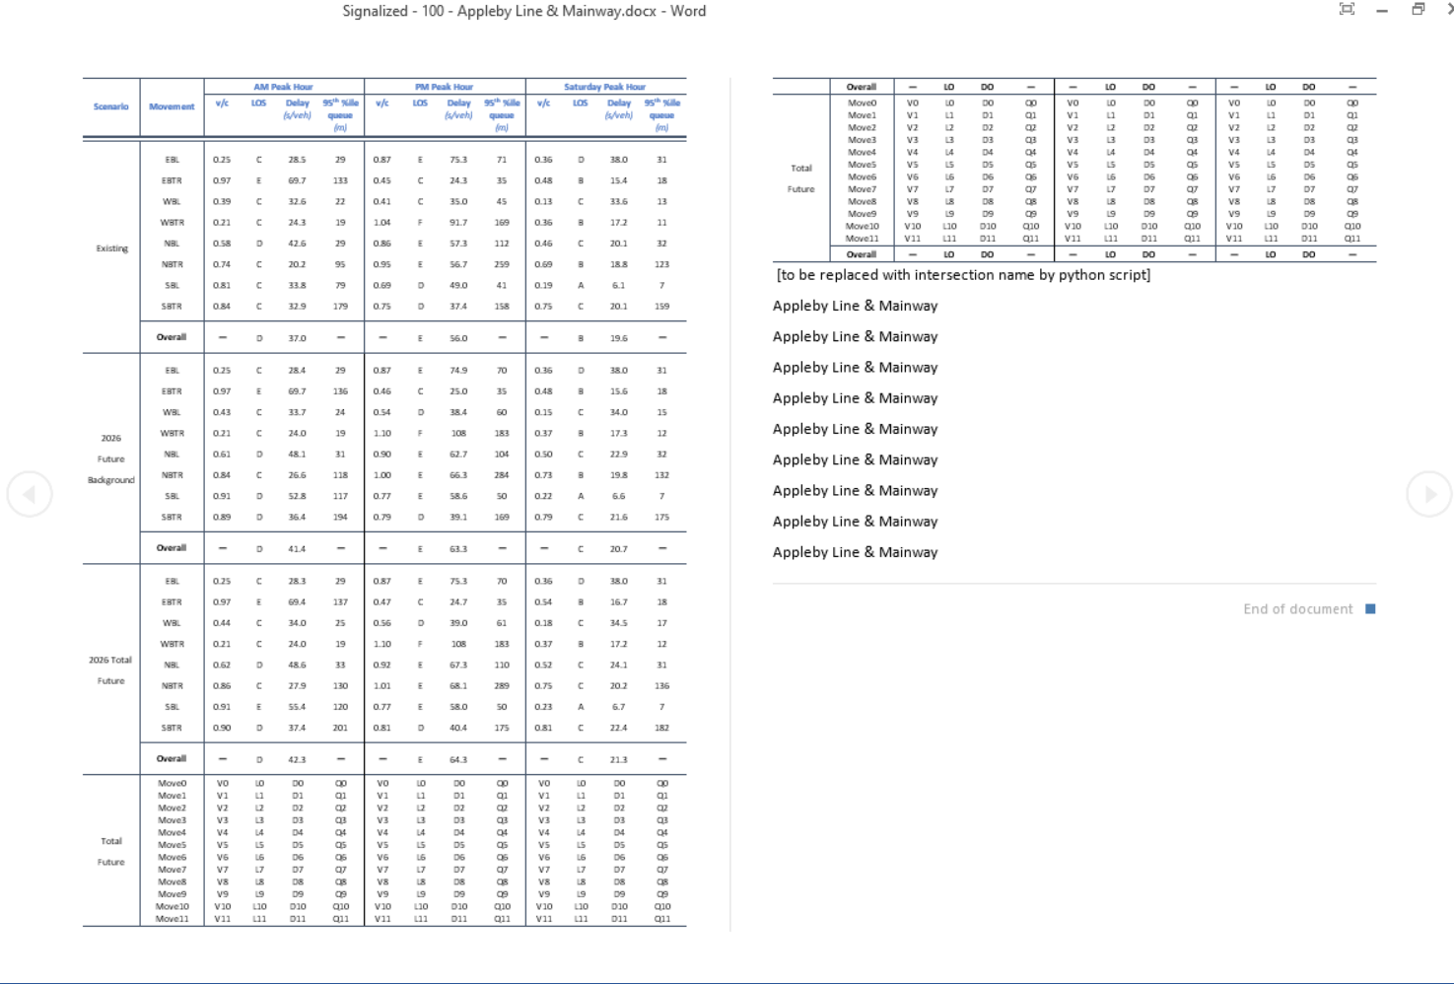

# USING OUTPUT

* I normally copy-paste cells (contents) from output tables into tables in report

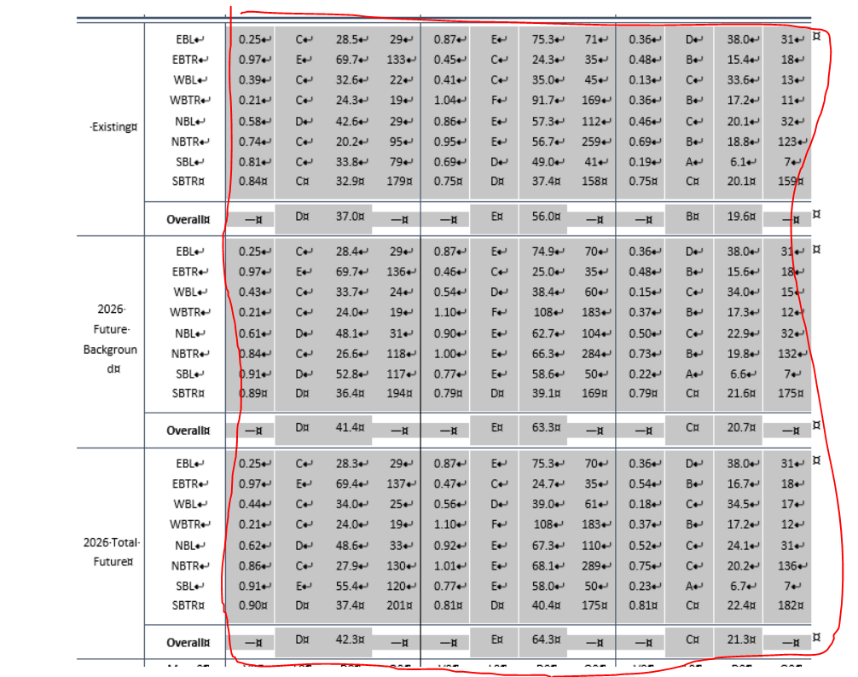

# Notes for the script.

* Depending on project, you will encounter unconventional peak hour names. You;ll need to adjust the code for this. The code has 3 sections for peak hour names (Starting around lines 709, 791, 863)

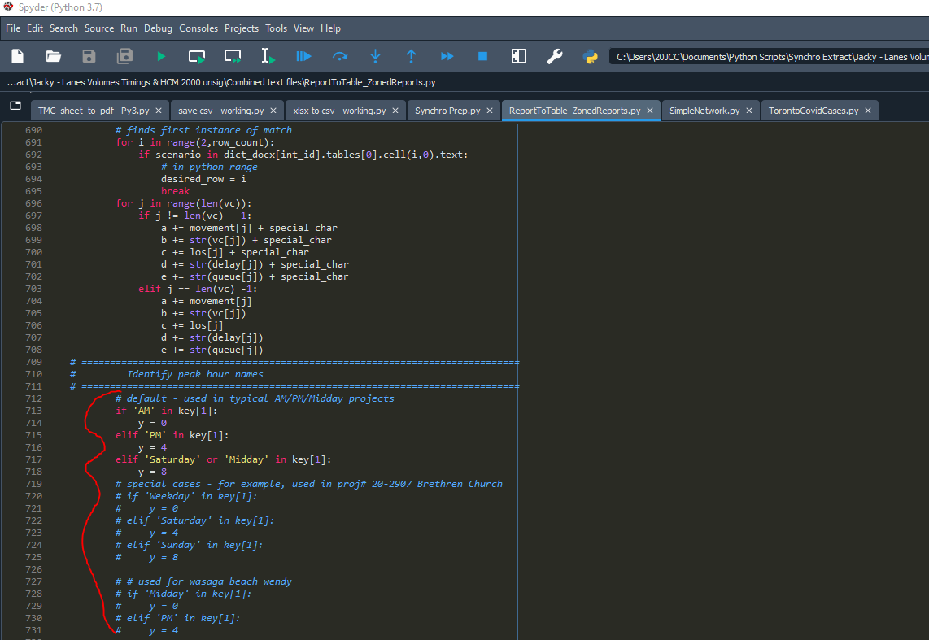

* Scenario names can be changed too. Example from other projects are kept in the script near the end.